**Report on Energy Drink Market Analysis for CodeX**

**ABOUT CODEX**

* German company operating in Food & Beverage Industry.
* Recently launched their energy drink product in 10 cities of India.
* CodeX is at 5th position in terms of market capitalization.

**1. Introduction**

The **objective** of this report is to present a comprehensive analysis of the energy drink market based on survey data collected from respondents. The analysis aims to uncover key insights into consumer preferences, demographics, brand perception, and purchase behavior, with the goal of informing marketing strategies and product development initiatives in the food and beverage industry.

**2. Dataset Description**

The dataset used for analysis consists of three main sheets:

dim_respondents: This sheet contains information about survey respondents, including unique identifiers (Respondent_ID), respondent names (Name), categorized age groups (Age_Group), genders, city IDs (City_ID), and tier classifications (Tier).

dim_cities: Provides details about cities, including unique city identifiers (City_ID), city names, and tier classifications.

fact_survey_responses: Contains responses to various survey questions related to energy drink consumption, brand perception, marketing channels, packaging preferences, and more.

**3. Data Preprocessing**

Created an "Age_Category" column using the IF formula to categorize respondents into age groups (Youth, Middle Age, Senior) based on their age.

**4. Analysis and Insights**

**Demographic Insights:**

**a. Who prefers energy drink more? (male/female/non-binary?)**

Analysis reveals that males exhibit a higher preference for energy drinks compared to females and non-binary individuals, with approximately 60.38% of respondents being male.

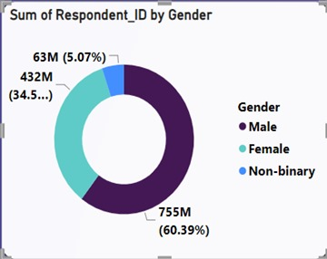

**b. Which age group prefers energy drinks more?**

The age group of 19-30 demonstrates the strongest preference for energy drinks, representing 55.20% of respondents, followed by the 15-18 age group at 23.76%.

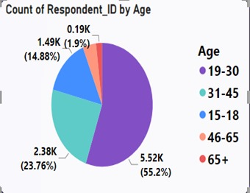

**c. Which type of marketing reaches the most Youth (15-30)?**

Social media emerges as the most effective marketing channel for reaching youths aged 15-30, with 48.13% of respondents in this age group citing social media as their primary source of energy drink advertisements.

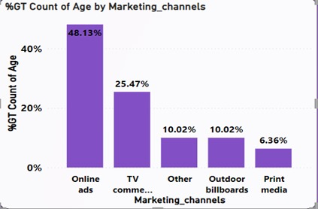

**Consumer Preferences:**

**a. What are the preferred ingredients of energy drinks among respondents?**

Caffeine emerges as the most preferred ingredient in energy drinks, with 38.96% of respondents expressing a preference for caffeine.

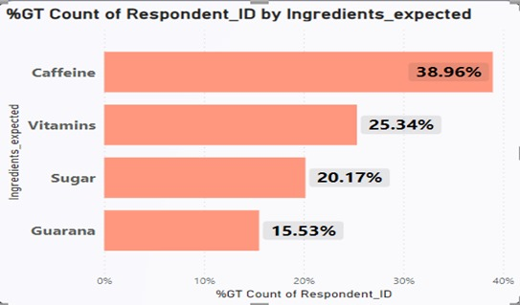

**b. What packaging preferences do respondents have for energy drinks?**

Compact and portable cans are the preferred packaging option for energy drinks, preferred by 39.84% of respondents, followed by collectible packaging at 30.47%.

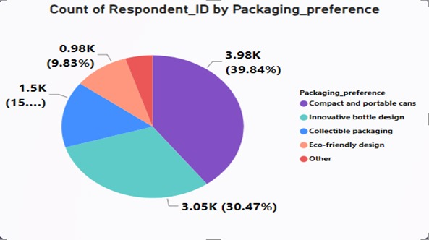

**Competition Analysis:**

**a. Who are the current market leaders?**

Coca-Cola emerges as the current market leader in energy drinks, commanding a market share of 25.38%, followed by Pepsi and Gangster.

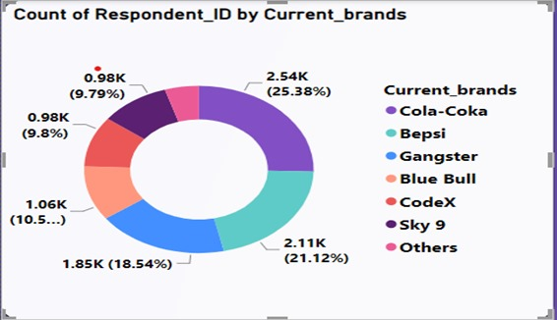

**b. What are the primary reasons consumers prefer those brands over ours?**

* For 27% of respondents, Brand Reputation is primary reason for choosing other brands over ours.Taste/flavour preference and Availability are two another major factors

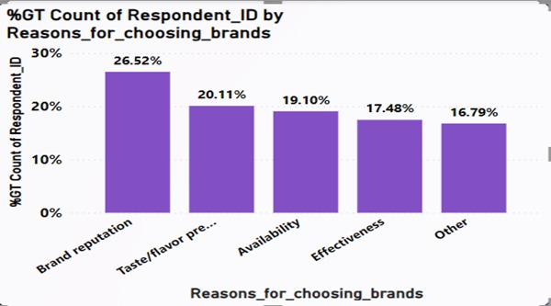

**Marketing Channels and Brand Awareness:**

**a. Which marketing channel can be used to reach more customers?**

Online ads are identified as the most effective marketing channel for reaching customers, particularly youths, with 40.2% of respondents citing online ads as their primary exposure to energy drink advertisements.

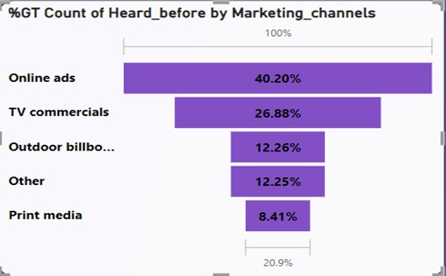

**b. How effective are different marketing strategies and channels in reaching our customers?**

* **Online ads** are mostly reaching youth of age **19-30**.

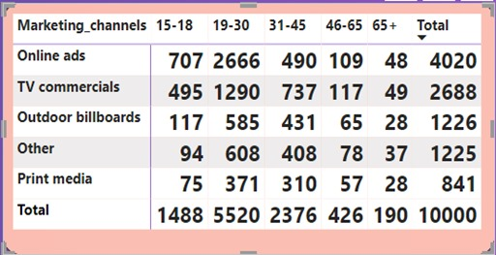

**Brand Penetration**

**a. What do people think about our brand? (overall rating)**

Brand perception for Codex energy drinks is predominantly neutral (6.0%), with potential for improvement in certain cities like Delhi and Lucknow where brand awareness is lower.

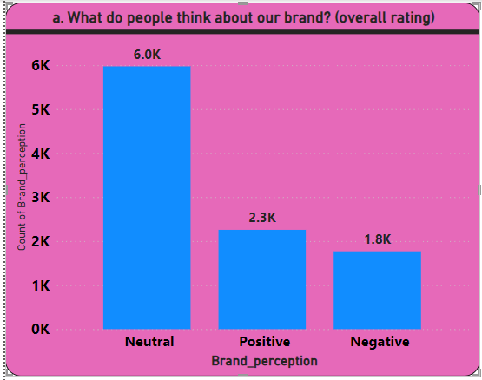

**b. Which cities do we need to focus more on?**

* Out of 2828 respondents from Bangalore, 1670 has not heard about our brand before, which accounts to 30%

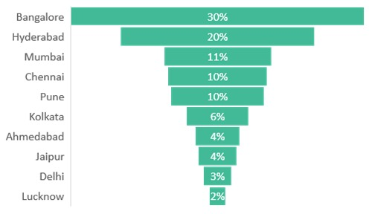

**Purchase Behavior:**

**a. Where do respondents prefer to purchase energy drinks?**

Supermarkets are the preferred purchase location for energy drinks, favored by 44.94% of respondents, followed by online retailers at 25.50%.

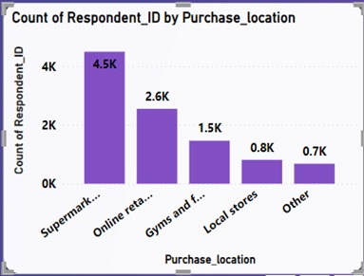

**b. What are the typical consumption situations for energy drinks among respondents?**

Typical consumption situations for energy drinks include before exercise (44.94%), increased energy needs (32.31%), and studying/working late (14.87%).

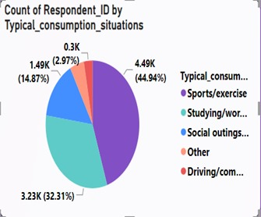

**c. What factors influence respondents' purchase decisions, such as price range and limited edition packaging?**

* 74% of respondents want price range to be 50-150.
* Limited edition packaging is not a influencing factor

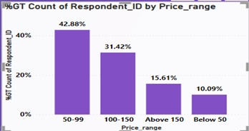

**Product Development:**

1. **Which area of business should we focus more on our product development? (Branding/taste/availability)**

**51%** of respondents have not tried our product before.

**Availability** and **Health concerns** are two major factors preventing users from trying.

**30%** of respondents who have tried out product rated taste experience 3.

We should focus on increasing brand presence and availability of our products

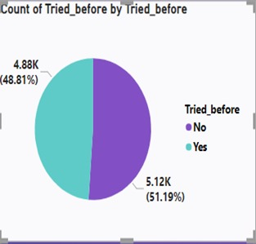

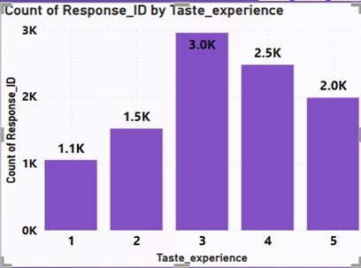

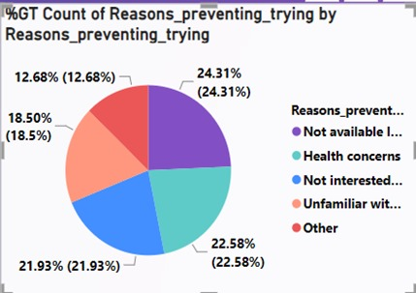

**5. Recommendations**

Based on the analysis, the following recommendations are proposed:

Invest in targeted marketing campaigns on social media platforms to effectively reach youths aged 15-30, leveraging the high effectiveness of social media channels.

Enhance brand reputation through branding initiatives and taste improvement strategies, focusing on building strong brand recognition and improving taste profiles to meet consumer preferences.

Expand distribution channels to improve availability, particularly in cities with low brand awareness such as Delhi and Lucknow, to increase accessibility and reach new customer segments.

Innovate packaging designs to meet consumer preferences for compact and collectible packaging, catering to the growing demand for convenient and visually appealing packaging options.

**6. Conclusion**

In conclusion, the analysis provides valuable insights into the energy drink market landscape, highlighting opportunities for market penetration and product improvement. By leveraging these insights and implementing the recommended strategies, brands can strengthen their market position and meet consumer needs effectively in the competitive food and beverage industry.

This detailed report provides a thorough analysis of the energy drink market based on survey data, offering actionable insights and recommendations to stakeholders in the food and beverage industry.